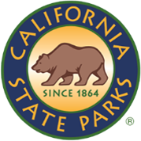
SDC OPEN SPACE

NEWSLETTER

ISSUE NO # 002| JUNE 2026
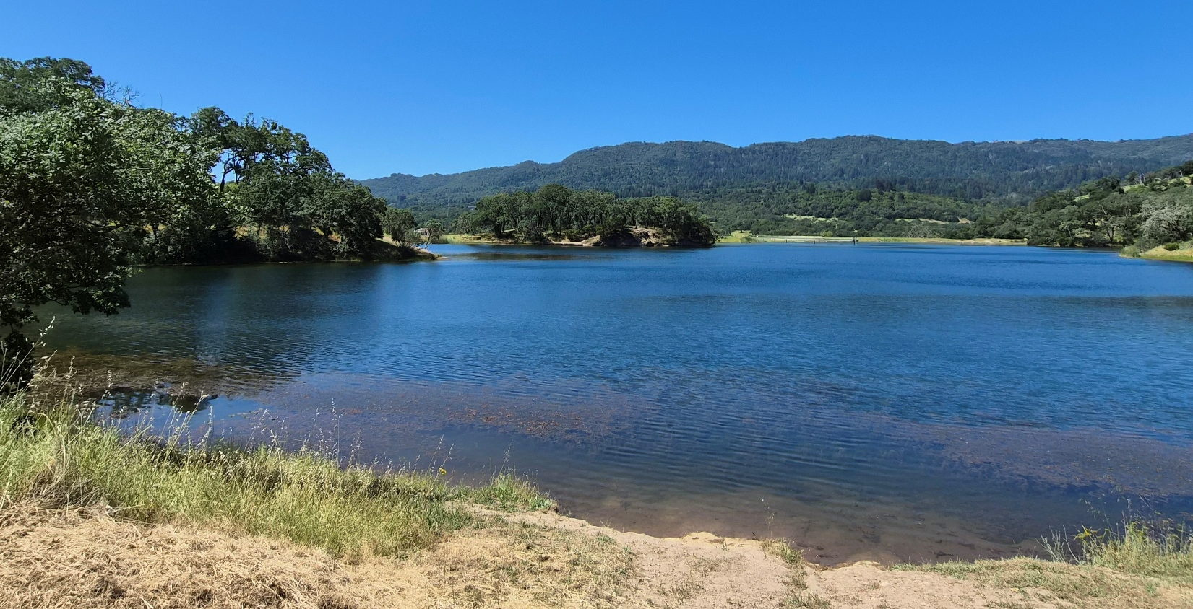
Caption: Lake Suttonfield. Photo by: Carmen Vanni, California State Parks

WELCOME!
Have you ever wondered about the words and acronyms we use to describe our parklands and programs? Here are some you may find at Sonoma Developmental Center Open Space: SDCOS: Sonoma Developmental Center Open Space. CSP: California State Parks. DPR: Department of Parks & Recreation. CWPP: Cannabis Watershed Protection Program.

Note: Since we are not stewards to the SDC core campus, we will not be using the acronym “SDC” to describe our park lands. We will use SDCOS.
Carmen Vanni (she/her)
State Park Interpreter I (PI)
Carmen.Vanni@parks.ca.gov
TABLE OF CONTENTS

Featured Article: Meet the Wildfire and Forest Resilience Program 4
What is the Latest News on the Cannabis Watershed Protection Program (CWPP)? 5
News & Updates 6
Calendar of Events 7

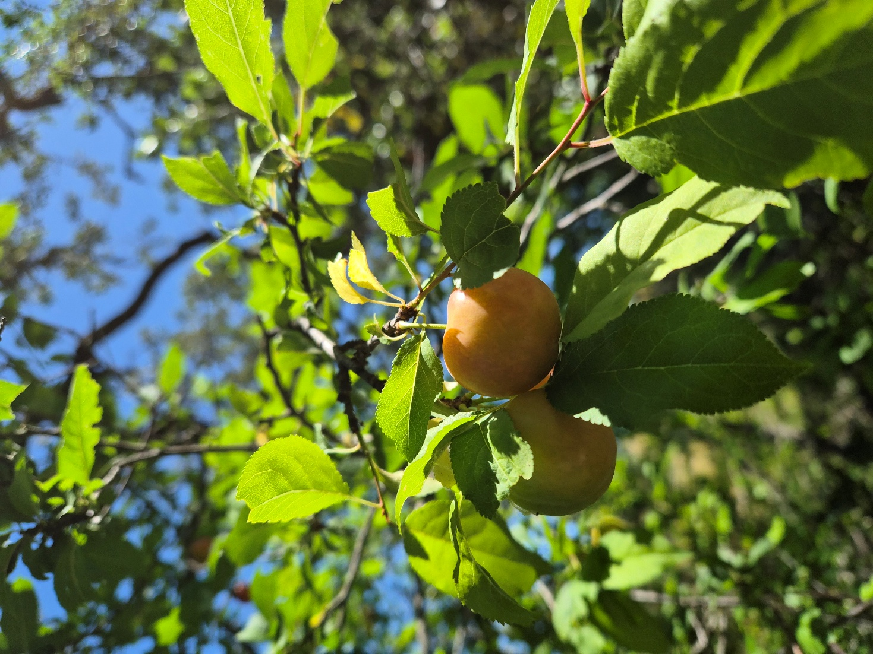
Photo by: Carmen Vanni, California State Parks

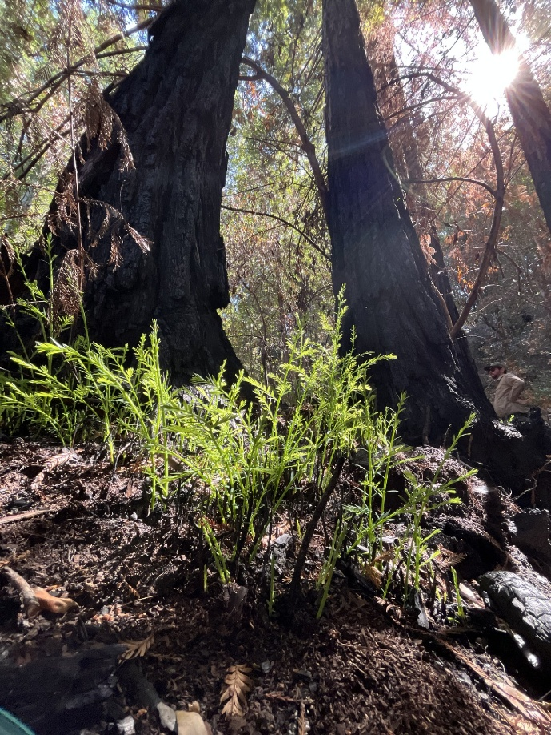
Featured Article: Meet the Wildfire and Forest Resilience Program
Caption: New redwoods sprout at Jack London SHP following a winter 2026 prescribed burn. Photo by: Ryan Forbes, California State Parks.
This article uses information from the Wildfire and Forest Resilience webpage from the California State Parks official website.
The next time you find yourself hiking around Sonoma Developmental Center Open Space, you may notice several piles of vegetation sitting around certain areas of the park. These piles contain invasive plants and/or other dead vegetal material and will be burned in a controlled process called pile burning.
Pile burning is one of many strategies California State Parks uses to steward our parks. Much of California’s ecosystems are adapted to fire and some plants, such as the famous coastal California redwood, thrive in this environment. They can protect themselves from fire due to their thick bark--and they can sprout again after losing their crown. However, due to years of fire suppression, with no fire to recycle built-up dead plant material, this accumulation can cause more intense fires when they do occur.
In response to the historic California wildfire season of 2020, Governor Newsom’s Wildfire and Forest Resilience Task Force released California’s Wildfire and Forest Resilience Action Plan in 2021. The Plan introduces a comprehensive framework for establishing healthy and resilient forests that can withstand and adapt to wildfire, drought, and a changing climate. California State Parks is a major contributor to this statewide plan.
In the Plan, California State Parks is specifically called to do the following:
- Scale up prescribed fire and fuel reduction programs.
- Expand collaboration with neighboring landowners and agencies to promote resilient and healthy forests at a landscape scale.
- Increase outreach and education to share best practices that support ecosystem services.
- Implement an effective monitoring program to gather information on the ecological benefits of these practices.
California State Parks has hired various scientists and trained fire professionals across the state to bring their knowledge and expertise to the Wildfire and Forest Resilience Program (WFRP), following the creation of the Wildfire and Forest Resilience Action Plan of 2021. For district-wide videos on the Wildfire and Forest Resilience Program, check out the official YouTube page here.
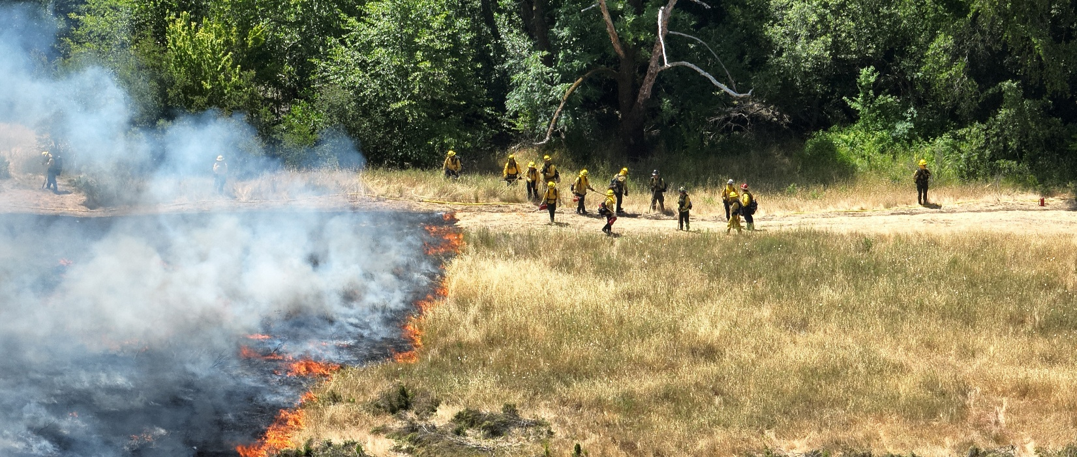
Caption: Prescribed burn at Sugarloaf State Park. Photo by: Ryan Forbes, California State Parks

What is the Latest News on the Cannabis Watershed Protection Program (CWPP)?
The Bay Area District is harnessing the funding and resources from the CWPP to start various long-term projects at SDCOS, one of which includes a set of panels interpreting the local watershed.
This natural resource-based project is like the cultural resource panel project discussed in Newsletter Issue #001. The major difference between the two is that this project is intended to be done in-house as much as possible, while the cultural resource panels have been partially outsourced to the Anthropological Studies Center at Sonoma State University. Both projects include developing internal documentation, park info sheets, brochures, and educational materials for interpreting watersheds and other park features.
During this process, we want to prioritize relevant local voices. Alongside our tribal partners and other partner organizations, we are seeking voices that have ties to the history of the Sonoma Developmental Center--whose open spaces we are stewarding today. Therefore, we are committed to connecting with stakeholders who are and/or work with individuals with disabilities. We hope that through the consultation and collaboration process, California State Parks can ensure that Sonoma Developmental Center Open Space becomes a park where accessibility is considered first.

If you have any questions, comments, anecdotes, or suggestions about accessibility for SDCOS park land, programming, or communications, please contact us via email at Carmen.Vanni@parks.ca.gov or call the Bay Area District Office at (707)769-5652 | 711, TTY Relay Service.
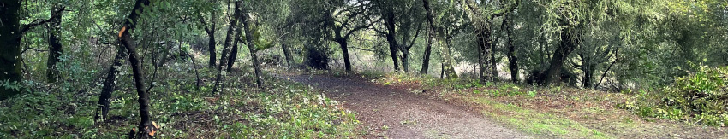

News & Updates

Fire Road Maintenance with CAL Fire
From May 27th to June 4th, California State Parks is partnering with CAL Fire to grade and maintain the Suttonfield Lake fire roads between Sunrise Road, Sonoma Valley Regional Park, and the CAL Fire station.
This work will improve access for patrol, maintenance, and resource management activities around Suttonfield Lake for the summer and fall seasons. Several pieces of heavy equipment will be staged at the building on Sunrise Road for the next few weeks while this work takes place.

Prescribed Burn – Lake Suttonfield
California State Parks in cooperation with CALFIRE plans to conduct Prescribed Burns in multiple parks around the Sonoma Valley including SDCOS, on weekdays between June 16th-30th, 2026 as conditions permit. Burns may also occur at Sugarloaf Ridge State Park and Jack London State Historic Park.
All burning depends on weather and air conditions that are favorable. If conditions are not suitable the burns will be rescheduled.
For more information about ongoing prescribed burns visit our Prescribed Fire Webpage.

CSP Event Calendar Gets a New Look
California State Parks is rolling out a brand-new way to discover park events on the official CSP website. Starting July 1st, visitors can view an interactable map of all state parks and their events, powered by ArcGIS. Visitors can filter their search results by date, county, park name, event type, virtual/in-person, and more. It’s never been easier to find your next state park event! See the new Event Calendar here.

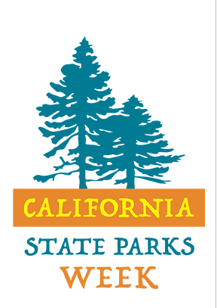
Calendar of Events

June

June 10th – 14th – California State Parks Week
California State Parks Week is an annual event that celebrates the amazing diversity of California’s State Park System. We invite Californians to celebrate the communities and cultures that make California special! Check out the State Parks Week event calendar here.

Saturday, June 13th – Guided Hike

Join us for a beginner-friendly hike on newly acquired State Park land at the Sonoma Developmental Center Open Space! Meet at the intersection of Harney and Railroad in Eldridge, California at 10 AM. Water, hats, and sturdy shoes are recommended.
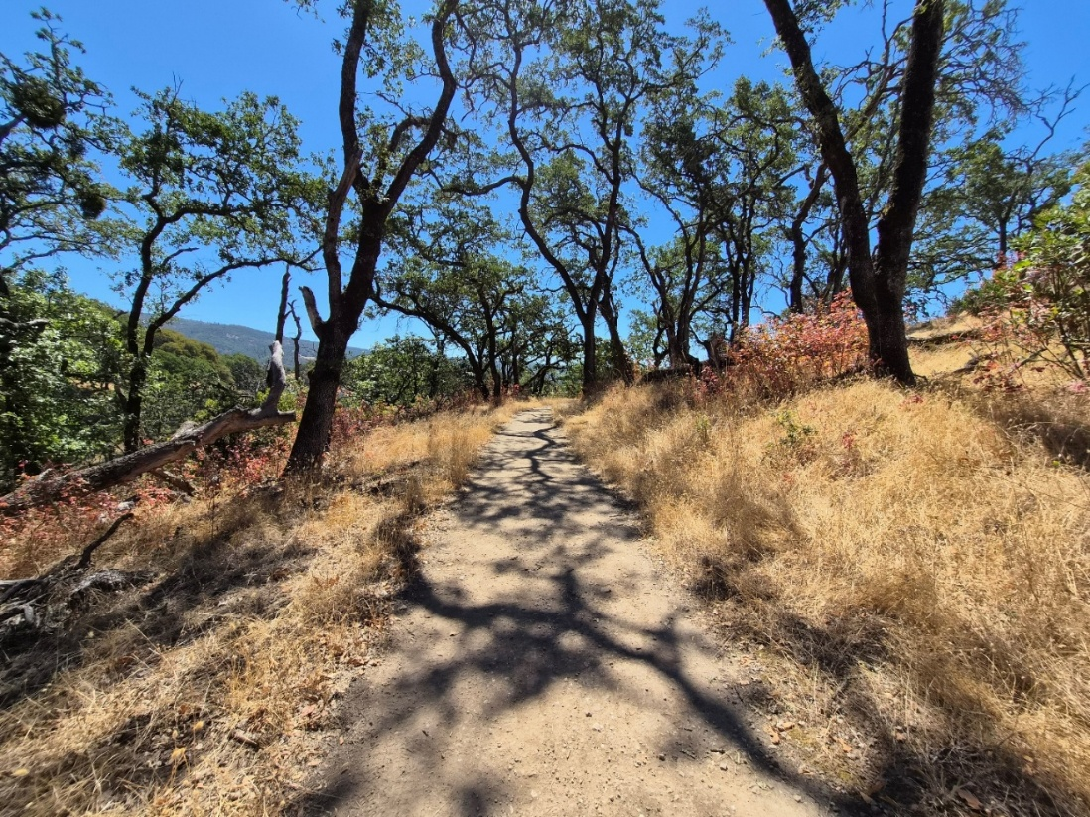
Caption: Trail around Lake Suttonfield. Photo by: Carmen Vanni, California State Parks.

CALIFORNIA STATE PARKS SUPPORTS EQUAL ACCESS. PRIOR TO ARRIVAL, VISITORS WITH DISABILITIES WHO NEED ASSISTANCE SHOULD CONTACT CARMEN VANNI AT (707)769-5652.
