ROBERTI-Z’BERG-HARRIS (RZH)

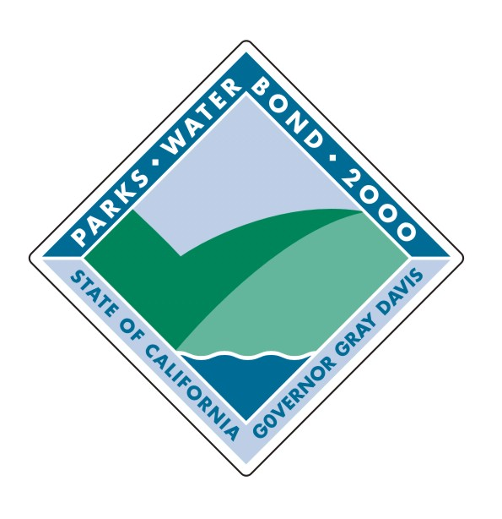
BLOCK (PER CAPITA) GRANT PROGRAM
ALLOCATIONS FOR 2000 BOND ACT

APRIL 23, 2001

Note: Allocations subject to Appropriation in California State Budget (Expected to occur in July 2001).

County and Regional Park District Allocations

Block (Per Capita) Grants

Urbanized Program
$52,145,000
Rate for Allocations: $1.61 per capita.
To be eligible a county must have a population of 200,000 or more and a regional park district must be located in an urbanized area. An “urbanized area” consists of a central city or cities and surrounding closely settled territory, as determined by the Department of Finance on the basis of the most recent verifiable census data. The most recent verifiable census data is the “Urbanized Areas” maps produced by the Bureau of the Census, an agency of the U.S. Department of Commerce, and based on the 1990 U.S. Census. (The next update of these maps will be based on the 2000 Census, but will not be available until late 2002 or early 2003).

Heavily Urbanized Program
$10,580,000
Rate for Allocations: $0.46 per capita.
To be eligible a county or regional park district must have a population of 1,000,000 or more.

Note: A county with no allocation is the result of an overlap with a district that operates and manages park and recreational areas and facilities for that population.

All populations are estimates as of January 1, 2000. Populations of city and county are based on the City/County Population Estimates Report E-1 prepared by the California Department of Finance and released May 3, 2000. Populations of districts are estimates based on the most recent verifiable census data and other population data that were furnished to the Department. Sources of population estimates for districts included County Planning Departments, Council of Governments or Association of Governments, Local Agency Formation Commissions, and County Registrars.
County and Regional Park District Block Grant Allocations for the RZH Urbanized and Heavily Urbanized Grant Programs (Combined Total).

City and District Allocations

Block Per Capita Grants

Urbanized Program
$78,217,000
Rate for Allocations: $2.91 per capita.
To be eligible a city or district must be located in an urbanized area. An “urbanized area” consists of a central city or cities and surrounding closely settled territory, as determined by the Department of Finance on the basis of the most recent verifiable census data. The most recent verifiable census data is the “Urbanized Areas” maps produced by the Bureau of the Census, an agency of the U.S. Department of Commerce, and based on the 1990 U.S. Census. The next update of these maps will be based on the 2000 Census but will not be available until late 2002 or early 2003.

Heavily Urbanized Program
$15,870,000
Rate for Allocations: $1.74 per capita.
To be eligible a city or district must have a population of 300,000 or more.

Note: A city with no allocation is the result of an overlap with a district that operates and manages park and recreational areas and facilities for that population.

All populations are estimates as of January 1, 2000. Populations of city and county are based on the City/County Population Estimates Report E-1 prepared by the California Department of Finance and released May 3, 2000. Populations of districts are estimates based on the most recent verifiable census data and other population data that were furnished to the Department. Sources of population estimates for districts included County Planning Departments, Council of Governments or Association of Governments, Local Agency Formation Commissions, and County Registrars.
City and District Block Grant Allocations for the RZH Urbanized and Heavily Urbanized Grant Programs (Combined Total).
City and District Block Grant Allocations for the RZH Urbanized and Heavily Urbanized Grant Programs.
City and District Block Grant Allocations for the RZH Urbanized and Heavily Urbanized Grant Programs.
City and District Block Grant Allocations for the RZH Urbanized and Heavily Urbanized Grant Programs.
City and District Block Grant Allocations for the RZH Urbanized and Heavily Urbanized Grant Programs.
City and District Block Grant Allocations for the RZH Urbanized and Heavily Urbanized Grant Programs.
City and District Block Grant Allocations for the RZH Urbanized and Heavily Urbanized Grant Programs.
City and District Block Grant Allocations for the RZH Urbanized and Heavily Urbanized Grant Programs.
City and District Block Grant Allocations for the RZH Urbanized and Heavily Urbanized Grant Programs.
City and District Block Grant Allocations for the RZH Urbanized and Heavily Urbanized Grant Programs.

Total 2000 Bond Act RZH Block Grant Allocations by county for all jurisdictions within each county (county, cities, and districts).

